Vegan Baked Beans
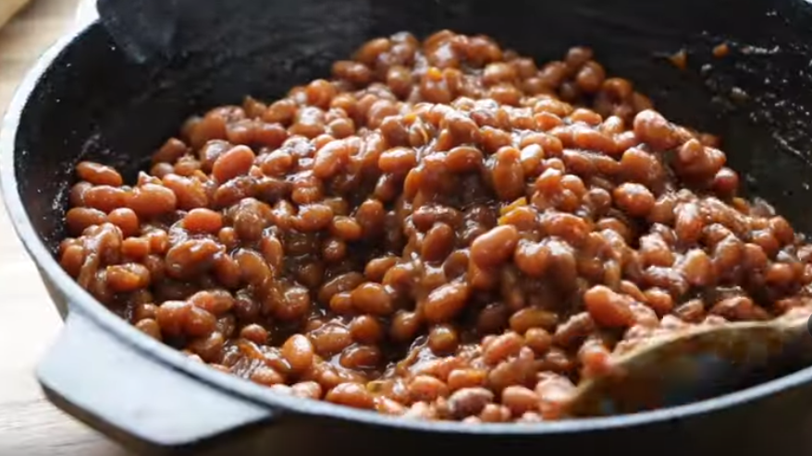

Ingredients
2 cups navy beans
4 cups water
1 chopped onion
2 tablespoons vegetable oil
1/2 cup molasses
1/4 cup maple syrup
1 teaspoon mustard powder
2 tablespoons tomato paste
2 tablespoons miso (substitute with Tahini and Bragg’s)
1 teaspoon of salt
pepper
3 cups water

Method
Place the beans in a bowl and cover with water. Soak 6 hours, rinse and drain.
In a cast iron skillet or in a oven proof saucepan heat the oil, add onion and sauté 5 minutes.
Add molasses, maple syrup, mustard powder, tomato paste, miso, salt and pepper. Mix well.
Add beans and 3 cups water.
Bring to a boil, cover with foil and bake for 3 hours at 325˚F or until the beans are tender.

