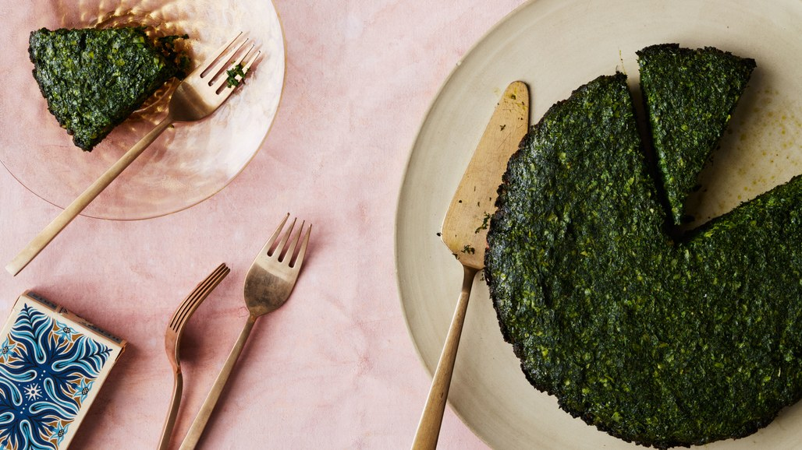
Persian Herb and Leek Frittata

Kuku sabzi (Persian frittata) tends to have less eggs than the typical fritter or omelette. They can be slightly sweet with dates and dried rose, or savory, like the one below. Try not to be diverted from all the greens that are suggested for this recipe. You really can use whatever hearty greens and herbs you like. It’s the ideal clean-out-the-fridge recipe.

Ingredients
- 5 tablespoons vegetable oil, divided
- 1 medium onion, finely chopped
- 1 medium leek, white and pale-green parts only, finely chopped
- 5 large eggs
- 1½ teaspoons kosher salt
- 1 teaspoon baking powder
- 1 teaspoon freshly ground black pepper
- ½ teaspoon ground turmeric
- 1½ cups finely chopped cilantro
- 1½ cups finely chopped dill
- 1½ cups finely chopped parsley
- 1 tablespoon dried fenugreek leaves

Preparation
Heat 2 Tbsp. oil in a 10" skillet over medium. Cook onion and leek, stirring occasionally, until very soft but not brown, 10–12 minutes. Transfer to a plate and let cool. Wipe out skillet; set aside.
Whisk eggs, salt, baking powder, pepper, and turmeric in a large bowl. Using a rubber spatula, mix in onion mixture, cilantro, dill, parsley, and fenugreek. (Egg mixture should look thick and very green.)
Heat broiler. Heat remaining 3 Tbsp. oil in reserved skillet over medium. Pour in egg mixture; spread evenly across pan with spatula. Cover and cook frittata until bottom is just set, 8–10 minutes. Uncover and broil, watching carefully, until top is set, about 1 minute. Let cool slightly, then slide out onto a platter.
Serves 8

