Spanish Garlic Zucchini | Calabacin al Ajillo Recipe
Course: Appetizer, Side Dish | Cuisine: Spanish | Prep Time: 10 minutes | Author: Albert Bevia  @ Spain on a Fork
Resting Time: 30 minutes | Servings: 4 | Cook Time: 15 minutes | Author: Albert Bevia  @ Spain on a Fork

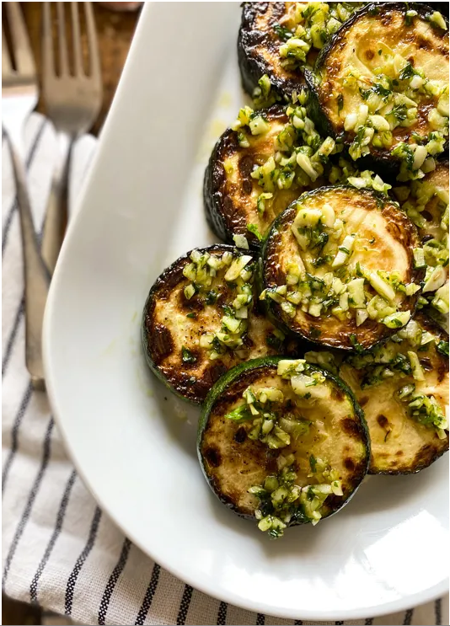

Ingredients
- 3 tbsp extra virgin olive oil 45 ml
- 2 zucchini
- 6 cloves garlic
- 1/4 cup fresh parsley 15 grams
- sea salt & black pepper
Instructions
- Cut 2 zucchinis (washed & patted dry) into thick rounds that are 1/2 inch (1.25 cm) thick, season the zucchini rounds with sea salt on both sides, then add to a colander, let them rest for 30 minutes
- Meanwhile, roughly chop 6 cloves garlic and add to a mortar, roughly chop 1/4 cup (15 grams) fresh parsley and add to the mortar, season with a little sea salt and using a pestle pound down until well combined, set aside
- After 30 minutes, transfer the zucchini slices into some paper towels (in a single layer) and pat completely dry, season with black pepper just on one side
- Heat a fry pan with a medium-high heat, after 3 minutes add in 2 tbsp (30 ml) extra virgin olive oil and start adding the slices of zucchini, in a single layer, so cook in batches, after 2 1/2 minutes flip the slices of zucchini to fry the other side, after a total cooking time of 5 minutes, remove the zucchini from the pan and transfer into a dish with paper towels, continue to cook in batches until done
- Once all the zucchini is done, transfer to a serving dish, then using the same pan, lower the fire to a low-medium heat, add in 1 tbsp (15 ml) extra virgin olive oil and the garlic & parsley mixture, mix and cook for 25 to 30 seconds, then eveny spread the garlic & parsley mixture over the zucchini, enjoy!

