Ultimate Vegan Lentil Walnut Loaf
Yield: 8 thick slices
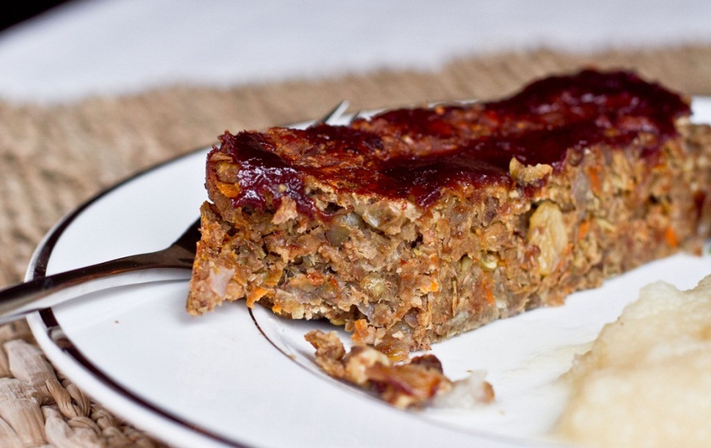
Ingredients:
- 1 cup dry lentils
- 3 cups vegetable broth
- 3 TBS ground flax seed
- 1/2 cup warm water
- 1 tbsp extra virgin olive oil
- 3 garlic cloves, minced
- 1 cup sweet onion, diced
- 1 celery stalk or green onion, chopped finely (optional)
- 1 medium carrot, grated
- 1/3 of an apple, peeled, grated (makes 1/3 cup grated apple)
- 1/4 cup raisins
- 3/4 cup toasted walnuts, roughly chopped
- 1 tsp kosher salt
- Freshly ground black pepper, to taste
- 1 tsp dried thyme
- 1/2 cup regular oats, ground into a flour (use GF oats for gluten-free option)
- 1 tbsp ground flax seed
- 3/4 cup breadcrumbs (I used 2 slices of Ezekiel bread, lightly toasted, and processed in food processor) Use GF breadcrumbs for gluten-free

Sweet Glaze
- 2 Tbsp ketchup
- 1 Tbsp Balsamic vinegar
- 1 Tbsp maple syrup
- 1 Tbsp apple butter

Directions:
Cook green lentils: In a medium sized pot, add 3 cups of water and a vegetable bouillon cube and boil water until cube is dissolved. Alternatively, you can also use already prepared veggie stock. Rinse lentils and pick over being sure to remove any small pebbles that may be in the mix. Add lentils, bring to boil, and reduce heat to low and simmer until liquid is absorbed and lentils are tender (about 40 minutes). Be sure to stir the lentils frequently so they do not stick to the bottom of the pot. Once the lentils are cooked, remove from heat and set aside to cool.
Preheat oven to 350 F and line a loaf pan with parchment so that parchment paper hangs over the edges by 2 inches.
Walnuts: Toast 3/4 cup of walnuts at 350F for about 6 minutes and then set aside to cool.
Flax egg: Mix 3 tbsp of ground flax with 1/2 cup warm water and stir well. Set aside for at least 5-10 minutes so it can gel up.
Prepare vegetable mixture: In a large skillet over medium heat, sauté onion and minced garlic for about 5 minutes on low-medium heat, being careful not to burn. After the onions are tender, add carrot and sauté for 2-3 minutes over low heat. Add grated apple, raisins, and chopped walnuts and sauté another minute or two. Add thyme, salt, and pepper to taste. Remove from heat and set aside.
Breadcrumbs: I took 2 slices of Ezekiel bread and lightly toasted them. Then I ripped up the slices and placed into my food processor and processed until small breadcrumbs were left. Alternatively, you can use store bought breadcrumbs too.
Process 75% of lentils and Mix everything together: Once the lentils are cooled, take 75% of the lentils and place into food processor. Process until mostly smooth (some small lentils will remain!). Now take the processed lentils and scoop into a large bowl. Add in the remaining 25% of non-processed lentils and place into bowl. Add the breadcrumbs, flax egg, veggie mixture, oat flour, and ground flax seed. Stir well with a spoon and then remove the spoon and mix well with your hands, pressing it through your fingers. Taste and adjust seasonings if necessary.
Dump the mixture into your loaf pan and spread out with a spoon. Now take your hands and press the mixture firmly and evenly into the pan.
Preparing Glaze: In small bowl combine all glaze ingredients. Spread evenly over loaf and bake, uncovered 45 minutes at 350F.
Cool for about 10-15 minutes and serve. Serves about 8 thick slices.

Article printed from Oh She Glows: http://ohsheglows.com
URL to article: http://ohsheglows.com/2011/01/01/ultimate-vegan-lentil-walnut-loaf/

